**The River Chapter #517**

******Order of the Eastern Star**

**cordially invites you to attend the**

**Visitation**

**by the Worthy Grand Matron of the Grand Chapter of Ohio**

**Debby Pitts**

**and**

**the Worthy Grand Patron of the Grand Chapter of Ohio**

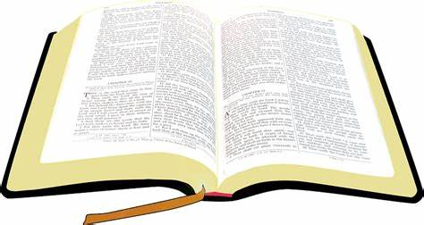**Rick Miller**

**for the**

**Reception**

**In honor of the**

**Grand Chaplain of the Grand Chapter of Ohio**

**Joseph Pacsuta**

**Friday June 9, 2023 7:30 P.M.**

**Cheryl Park Howard Park**

**Worthy Matron Worthy Patron**

**Berea Masonic Temple**

**366 Eastland Rd.**

**Berea, Ohio 44017**