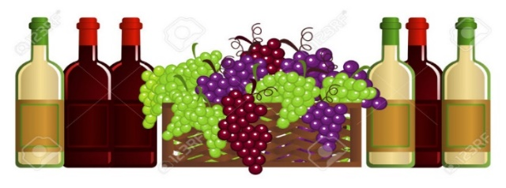
3rd ANNUAL WINE TOUR TO BENEFIT CHILDRENS DYSLEXIA CENTER IN CAMBRIDGE
OCTOBER 12, 2024

Tour Highlights:
- Buckeye Winery in downtown Newark
- Buckeye Lake Winery in Thornville
- Rockside Winery and Vineyard in Lancaster
- Annie’s Wine Cottage in Powell
- Blend of Seven Winery in Delaware – Dinner and silent auction

For those who want lunch, food is available for purchase at Buckeye Lake Winery and Rockside Winery. It is not included in the price of the tour. You can check the menu and prices on their websites.

All profits benefit the Children’s Dyslexia Center in Cambridge, which provides a free 2-year tutoring program for children diagnosed with dyslexia. You can help make a difference in a child’s life.

Cost: $150 includes transportation aboard a deluxe motorcoach, wine tastings at 5 wineries, dinner at Blend of Seven Winery, and all taxes and gratuities at the wineries

DEPARTURE POINTS: 9:15 am Ohio University Zanesville, 1425 Newark Rd., Zanesville
(use main entrance at traffic light, turn right to the back of the lot)
10:00 am Walmart, 1315 N. 21st St, Newark

Questions to Brooke Anderson (740-607-6642) or Conrad Wilkins (740-819-6159)

Reservations by September 14, 2024

Checks payable to Muskingum #485 sent to Brooke Anderson, 5405 Heritage Dr, Nashport OH 43830
No refunds after September 14, 2024

Arrangements and transportation by Brewster Travel, 82 W. Liberty St., Martinsburg OH
_ _ _ _ _ _ _ _ _ _ _ _ _ _ _ _ _ _ _ _ _ _ _ _ _ _ _ _ _ _ _ _ _ _ _ _ _ _ _ _ _ _ _ _ _ _ _ _ _ _ _ _ _ _ _ _ _ _
Separate form for each person please. Reservations by September 14, 2024

Name ________________________________________________________________________

Address _______________________________________________________________________

Phone _____________________________ Email ______________________________________

Choice of Dinner Sandwich at Blend of Seven
____ BBQ Chicken _____ Smoked Pulled Pork Sandwich _____ Smoked Steakburger

Emergency Contact person ________________________________________ Phone _____________
(someone who will not be on the bus as well)

