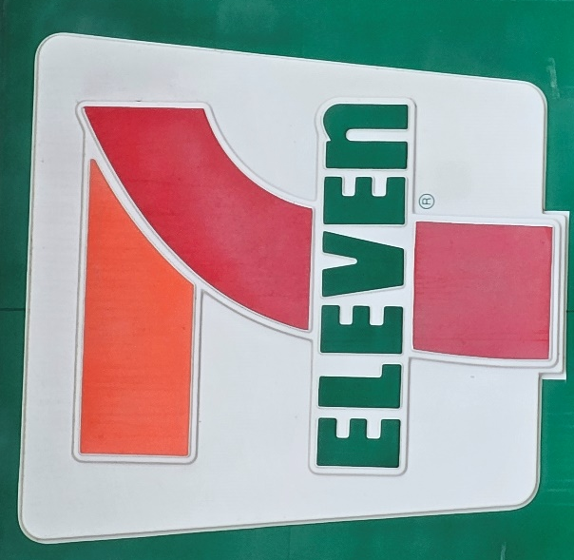
Districts 7 & 11
cordially invites you to a
BBQ Dinner Fundraiser
benefitting
Little Debbie’s Treasures &
Todd’s Weaving Warriors

Sunday July 28, 2024 at 5pm
Dinner cost $20 per person

At the home of Susie and Larry Mayer
875 State Route 734, Jeffersonville OH

BBQ Dinner with Pulled Pork, Sides and Dessert,
Silent Auction, Reverse Bead Auction and more!

Entertainment by WGP Harley Maynard

Reservations Due July 20, 2024

Reservations to Bonnie Chapin, 102 Bauer Street, Edon OH 43518, 419-272-2504 or bjchapin@frontier.com
Please make your check payable to Todd’s Weaving Warriors

