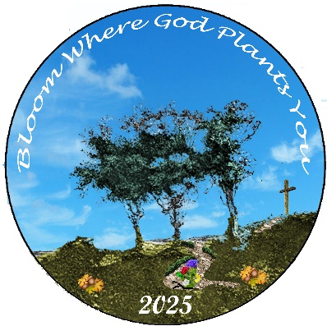

DISTRICTS

LITTLE SCHOOL #1 **aka Meet the Deputy**

(A Little Bit of Everything you need to start your year)

WHO: All members of District

WHAT: An Afternoon of Learning and Fellowship

* Greet the DGM and District Charities Director
* Introductions, Installation and General Procedures
* Distribute Packets from the Line Grand Officers
* Hear Plans for the state-wide charities
* Time for questions and answers
* Fellowship and Food

WHEN: Sunday, October 6, 2024 2:00 PM

WHERE: Carroll Chapter, 75 3rd St. NE, Carrollton

DRESS: Casual BUT please no jeans!

BRING: Ritual, Red Book, Notebook and Pen

SEE YOU THERE!