Toronto, Niagara-on-the-Lake, and The Finger Lakes

**Featuring**

**Nine Meals, Two Theater Shows, and Two Wine Tastings**

 **plus Great Attractions**



**July 21-25, 2025**

***Passport Required***

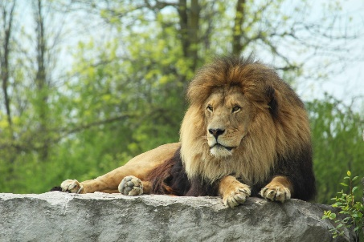**Package includes:**

* **Motor Coach Transportation (departures from Cleveland and Troy)**
* **Four nights of rooms (2 in Toronto, 1 in Niagara-on-the Lake, 1 in the Finger Lakes region)**
* **Four breakfasts**
* **Four dinners (dinner cruise, one at the Prince of Wales or Queens Landing Hotel, and two in Toronto)**
* 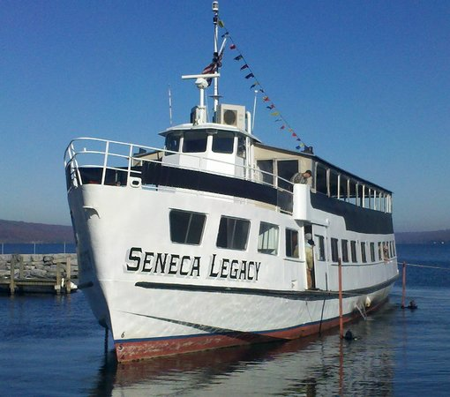**Made in America Store** (Troy bus does not make this stop) **–** The only “brick and mortar” general merchandise store in the world that sells exclusively 100% American-made products.
* **Admissions to Casa Loma**
* **CN Toronto Eaton Center Mall –** Time to shop & browse.
* **Tickets to a Broadway Show at one of the Toronto theaters**
* **Admissions to the African Lion Safari –** Get closer than you ever imagined to over 1,000 exotic bird and animal species from around the world.
* **Tickets to one of the Shaw Festival Shows**
* 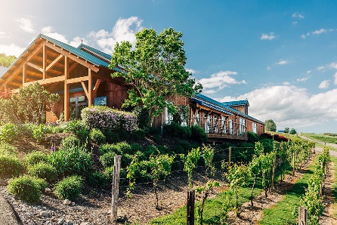**Winetasting at one of the local wineries in the Finer Lakes region**
* **Dinner Cruise aboard Captain Bill’s Seneca Legacy Ship**
* **Admissions to the Glenn Curtiss Museum –** Dedicated to the memory of pioneer aviator, Glenn Curtiss, the museum contains a priceless collection relating to early aviation and regional history
* **Time to explore downtown Hammondsport, NY**
* **Tour, wine tasting, & lunch at Bully Hill Vineyards**

**$1665 per person (double) $2115 (single) / $1515 per person (triple)**

**$100 deposit to book (non-refundable after March 1, 2025) / additional payment of $600 by April 1, 2025**

**Balance by June 15, 2025 - passengers cancelling after balance paid will be refunded all money received from suppliers.**

**Optional travel insurance is available through NTA Travel Protection; for this recommended protection, call (800) 388-1470**

**Be sure to mention Great Day! code # 356116 for this tour, which will add protection if you are concerned**

**over refunds should you have to unexpectedly cancel. Details are available through NTA Travel Protection.**

**For More Information or to make reservations, please send in the form**

**Or call Marlena, Alicia, or Ryan at Great Day! Tours at (440) 526-5350 or (800) 362-4905**

- - - - - - - - - - - - - - - - - - - - - - - - - - - - - - - - - - - - - - - - - - - - - - - - - - - - - - - - - - - - - - - - - - - - - - - - - - - - - - - - - - - - - - - - - - - - - - -

**REGISTRATION FORM (PLEASE PRINT) – Toronto, Niagara-on-the-Lake, & The Finger Lakes**

Name ________________________________________________ Address ____________________________________________________

City, State, Zip _________________________________________ Special needs? ______________________________________________

Home Phone (_________) ________________________________ Cell Phone (__________) _____________________________________

Sharing Room with ______________________________________ Also sharing, if applic, with ___________________________________

Boarding Location Cleveland (Richfield) __________ Troy __________

**Make checks payable to Great Day! Tours and mailed to Great Day! Tours / 375 Treeworth Blvd / Cleveland, Ohio 44147**

**You can also secure your reservations by calling Great Day! Tours before mailing the form . . . (440) 526-5350 or (800) 362-4905**