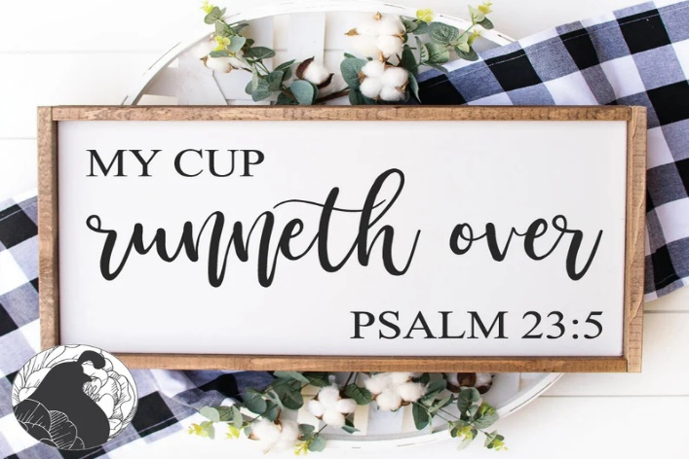

**INVITATION TO INSTALLATION OF OFFICERS**

MARY CHAPTER #9

MARYSVILLE MASONIC CENTER

OCTOBER 16, 2024

7 PM

NANCY RIDER, WM

CHARLES HALL, WP

GAYLE SUTHERIN, INSTALLING OFFICER.

HOME CHAPTER OF

DEBBIE SOMERLOT

ASSOCIATE GRAND MATRON

OF THE GRAND CHAPTER OF OHIO