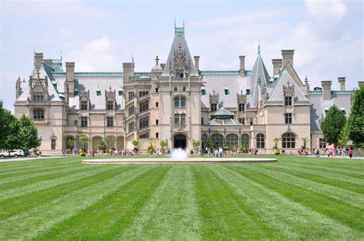

***The Biltmore Estate and WFIRM***

An OES trip supporting Regenerative Medicine

June 2-5, 2025 (4day-3night)

**The trip includes:**

Round trip deluxe motorcoach with 1 bus and pickup in Grove City.

**THE BILTMORE ESTATE, Asheville NC**

2 nights Village Hotel on Biltmore Estate

Length of stay daytime admission tickets and one self-guided audio guide

Two breakfasts at the Village Social

One group lunch at the Stable Café

One Box lunch

One $50.00 gift card per guest to use at the Biltmore

Round trip porterage

Miscellaneous Tax and Gratuities

**THE HISTORIC BROOKSTOWN INN, Winston-Salem, NC**

1 night lodging including wine and cheese afternoon reception and milk and cookies at bedtime

Delicious buffet breakfast

Catered farewell dinner in the Inn

**WFIRM tour, lunch and private meetings with Dr. Anthony Atala**

Meet the faculty, private tour the labs and facility, have lunch with faculty and meet with Dr. Atala.

**Pricing, per person:**

|  |  |  |  |
| --- | --- | --- | --- |
| **SINGLE** | **DOUBLE** | **TRIPLE** | **MISC** |
| $1370.00 | $1065.00 | $996.00 | Please designate  handicap |

**Deposit $150.00 per person by 12/1/24 (non-refundable)**

**Final payment due by 04/01/25**

**Checks payable to:**

**Fayette Travel Centre P.O. Box 266 Mt. Sterling, OH 43143**

********************************************************************************************

***Reservation form for Biltmore Estates and WFIRM trip.***

|  |  |  |  |
| --- | --- | --- | --- |
| ***SINGLE*** | ***DOUBLE*** | ***TRIPLE*** | ***MISC*** |
| ***$1370.00 per person*** | ***$1065.00 per person*** | ***$996.00 per person*** | ***Please indicate handicap*** |

***Inclusions:***

***3 nights lodging***

***3 breakfasts***

***3 lunches***

***1 dinner***

***$50.00 gift card at the Biltmore***

***Porterage at the Biltmore***

***Miscellaneous taxes and gratuities***

***\*\*\*\*\*\*\*\*\*\*\*\*\*\*\*\*\*\*\*\*\*\*\*\*\*\*\*\*\*\*\*\*\*\*\*\*\*\*\*\*\*\*\*\*\*\*\*\*\*\*\*\*\*\*\*\*\*\*\*\*\*\*\*\*\*\*\*\*\*\*\*\*\*\*\*\*\*\*\*\*\*\*\*\*\*\*\*\*\*\*\*\*\*\*\*\*\*\*\*\*\*\*\*\*\*\*\*\*\*\*\*\*\*\*\*\*\*\****

Name: __________________________________________________________

Name: _________________________________________________________

Address: _________________________________________City:_________________________State:_______Zip:______

Phone: _____________________Cell: ________________ Email: ______________________________________________

Type of Room request: single____________ double_______________ triple_______________

Special requests: _____________________________________________________________________________________

***Non-Refundable Deposit of $150.00 is due no later than December 01, 2024***

***Final payment due by April 01, 2020***

***Please make checks payable to THE FAYETTE TRAVEL CENTRE***

***Credit card accepted with a 4% service charge***

***Number of travelers_________________ x $_________________ = $__________________________________***

***Amount sent $______________________________________ Date sent $____________________***

***All arrangements made by***

***FAYETTE TRAVEL CENTRE***

***“Helping you PACKUP since 1986”***

***ORTA 8724001***

***P.O. Box 266 * Mount Sterling, OH 43143***

***740-335-6555***

***peg@fayettetravel.com***