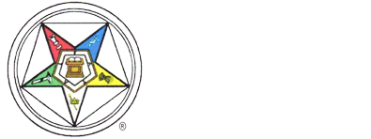
Rob Morris Membership Program 2024-2027

Rob Morris Membership Award Request Form
- Has Completed 300 points for Rob Morris Membership Jewel and/or
- Has Completed 300 points for Triennium Bar
100 points First Line Signer of a Petition once they receive the Degrees
50 points Second Line Signer of a Petition once they receive the Degrees
50 points First Line Signer on Affiliation from Reinstatement

This is to certify that:
Name of Member _________________________________________________
Address _________________________________________________________
City __________________________ State _________ Zip Code ____________
Date Submitted ____________________

Attest:
Name of Chapter Secretary ________________________________________
Name and Number of Chapter ______________________________________
Mailing Address _________________________________________________
City ________________________ State __________ Zip Code ____________
Phone _______________________ Email ______________________________

Chapter Seal Chapter Secretary Signature ________________

If to be sent somewhere else, please indicate on back of form.
Forms are to be sent to:
Richard Naegele, Membership Chairman, 4210 Overton Ave., Nottingham, MD 21236-4010
Email: OESMembership24.27@gmail.com

