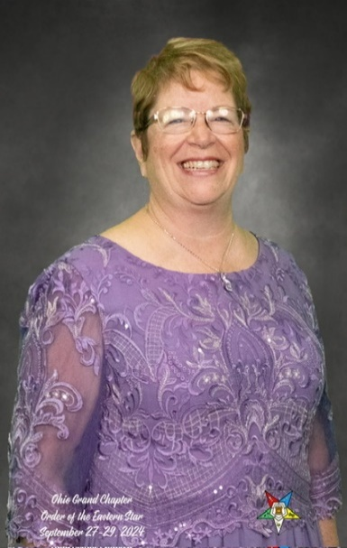

Saturday May 24, 2025 – 1:00 p.m.

Mary Chapter #9, 330 S. Main Street, Marysville