



Murder By Meatball

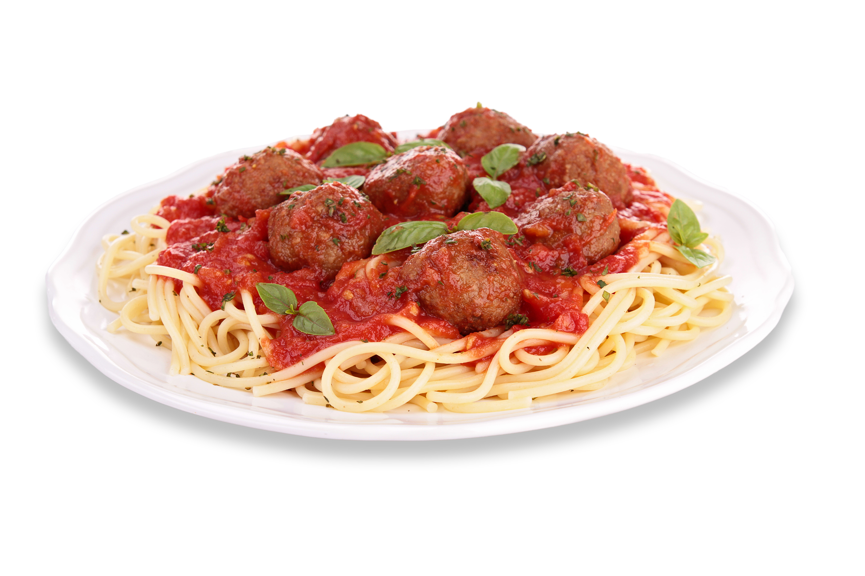

***For more information and tickets contact:***

***Dorothy Ballard - 330-285-1324***

***email - DottyBallard@gmail.com***

***Barb Stuart - 330-477-1410***

***Pam Miller - 234-252-9033***

**N. Canton Masonic Temple**

**805 Orchard Ave. NE**

**N. Canton, OH 44720**

**ALL YOU**

**CAN EAT!**

Friday, May 2, 2025

6:30 PM

Come out and support your District Charities with some   
yummy spaghetti, salad, bread, and dessert!

**$20.00 PER PERSON**