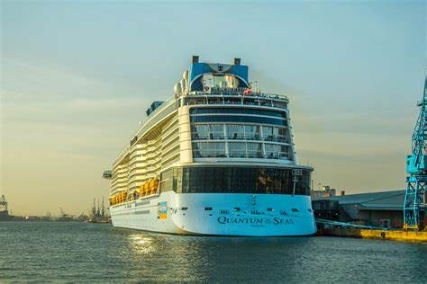

***It’s Cruise time 😊 Can’t wait to see you!! Everyone welcomed!!***

***Come and join us for a fantastic winter Regenerative Medicine Cruise***

***ROYAL CARIBBEAN’S beautiful Quantum of the Seas: Mexican Riveria Cruise***

***January 21-27, 2026***

***Balcony : $1160 ; Oceanview : $975; Inside: $825 (per person rate, based on double occupancy)***

***Triple and quad rates available upon request***

***(portion of the cost benefits Regenerative Medicine)***

***\*\*Roundtrip air, transfers and hotels for pre-cruise available by request***

***\*\*Optional cancellation insurance and gratuities may be added too.***

***Deposit of $250 per person due ASAP***

***(deposit includes $100 nonrefundable reservation fee)***

***Final payment by 10/15/25***

***\*\*\*\*\*\*\*\*\*\*\*\*\*\*\*\*\*\*\*\*\*\*\*\*\*\*\*\*\*\*\*\*\*\*\*\*\*\*\*\*\*\*\*\*\*\*\*\*\*\*\*\*\*\*\*\*\*\*\*\*\*\*\*\*\*\*\*\*\*\*\*\*\*\*\*\*\*\*\*\*\*’***

***Last Name:_______________________________________________________________***

***First and Middle names: __________________________________________________***

***Date of birth: Month:___________Date: _______________ Year: ________________***

***Passport #_____________________Issue Date: _______________Expires: ________***

***Royal Caribbean Crown and Anchor #_____________________________________***

***Address: _________________________________________________________________***

***City/state/zip: ___________________________________________________________***

***Phone:___________________________________________________________________***

***Email: ___________________________________________________________________***

***Emergency contact: ______________________________________________________***

***Relationship: _____________________________Phone: ________________________***

***Medical/Dietary needs: __________________________________________________***

***Sharing with: ____________________________________________________________***

***Special requests: ________________________________________________________***

***Make checks payable to: Fayette Travel Centre***

***Credit card #_________________________________________________***

***Expiration date:_____________________ cvv: ____________________***

***Name on card: _______________________________________________***

***Insurance accepted: _______________ Insurance declined: _____***

***All arrangements made by Fayette Travel Centre * PO Box 266 * Mt. Sterling, OH 43143 * 740-335-6555***