Ahoy Matey !

 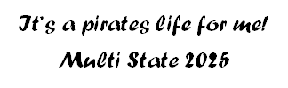

Seized by Michigan Grand Officers

It’s a pirate’s life for me! Multi State 2025

**August 16, 2025**

Tecumseh Masonic Temple

700 Bishop Reed Drive

Tecumseh, MI 49286

**Dress code: Ye old pirate garb!**

**Or Business Casual**

**Registration-4:00 p.m.**

**Dinner: 5:30 p.m.**

**Entertainment to follow**

**RANSOM OF $47.00**

**Checks made payable to: Grand Chapter OES of MI**

**Sent to: Colleen Wilcenski**

**10696 Ferry Road**

**Charlevoix, MI 49720**

**Phone: 231-675-2273**

**Email:** [**cmwilcenski@gmail.com**](mailto:cmwilcenski@gmail.com)

 **Michigan’s Hosting**

 **Ohio, Wisconsin, Illinois,**

**Indiana, Missouri, Kentucky**

**We look forward to seeing you!**

