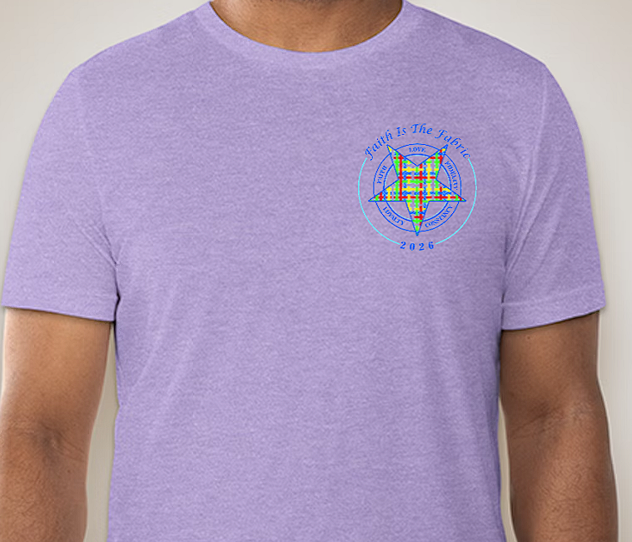
Todd’s Weaving Warriors T-shirt Order Form

$25 Per Shirt ($5 extra for shipping)
Name
Address
Phone Num.
Size | S:__ M:__ L:__ XL:__ 2X:__ 3X:__ 4X:__ 5X:__
Total
Cash or Check | Cash / Check
Pick Up | Grand Chapter / EOP: ___________ / Shipped
Sizes from Small to 5XL

For additional payment options contact Kristel Evans at kristel.evans2009@gmail.com
Please make all checks payable to Todd’s Weaving Warriors

