
You are Cordially
Invited to the

118th Annual
Installation of Officers
Bryan Chapter #248

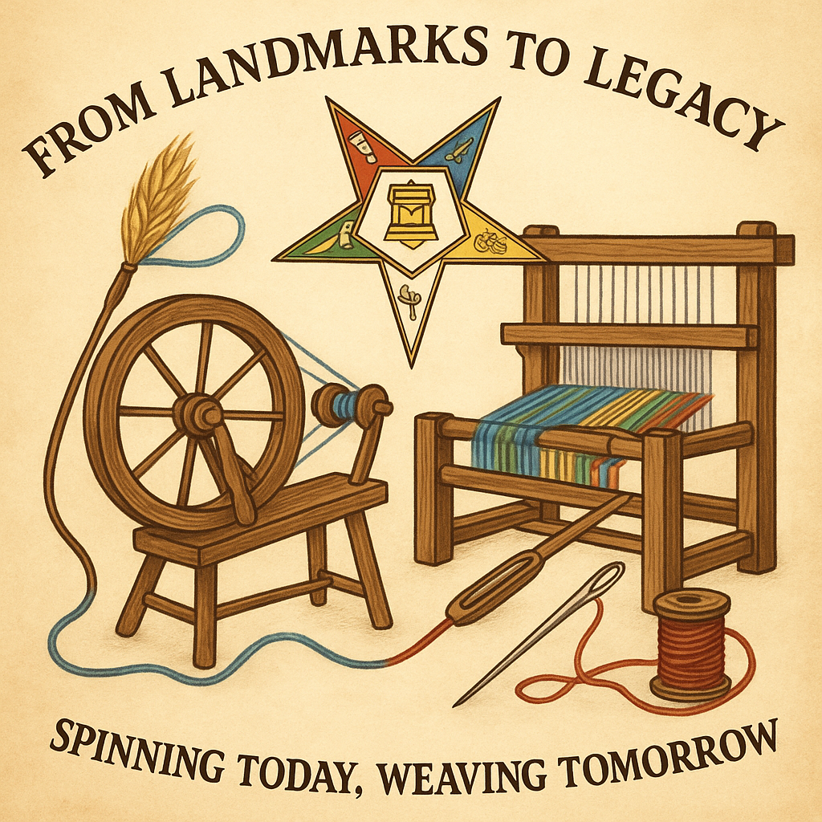
From Landmarks
To Legacy:
Spinning Today,
Weaving Tomorrow

Saturday, November 15, 2025 at 2:00 pm
Bryan Masonic Center
117 N. Lynn Street, Bryan OH 43506

Installing Officer Debbie Somerlot, Worthy Grand Matron

Home Chapter of 2026
Worthy Grand Patron and Grand Electa

Kalyn Bruce Todd Evans
Worthy Matron Elect Worthy Patron Elect

Diana Evans
Secretary

