  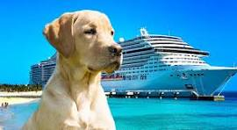  - General Grand Chapter  Service Dog Cruise to Alaska  - Princess Cruises: 7-Day Inside Passage with Glacier Bay National Park, Round-Trip Seattle!  Dates: May 1-8, 2027  Ports: Seattle, Juneau, Skagway, Ketchikan, Victoria  Pricing Information:  Interior Cabin: Category IB  - Double Occupancy: $1,449.00 Total Per-Person, Cruise Only  - Single Occupancy: $2,499.00 Total Per-Person, Cruise Only  Balcony Cabin: Category BC  - Double Occupancy: $2,159.00 Total Per-Person, Cruise Only  - Single Occupancy: $3,919.00 Total Per-Person, Cruise Only  Balcony Cabin: Category BB  - Double Occupancy: $2,169.00 Total Per-Person, Cruise Only  - Single Occupancy: $3,939.00 Total Per-Person, Cruise Only | Let’s Go Cruising!  ____  Making Lasting Memories Together!  ____  SPACE IS LIMITED! RESERVE YOUR SPOT TODAY!  ____  To Reserve Contact:  All World Travel  Garrett Snowbeck  (480) 585-2848 garrett@awtaz.com  Debbie Tanner, GGC General Chairman, Service Dogs  ggcsevicedogs@yahoo.com


