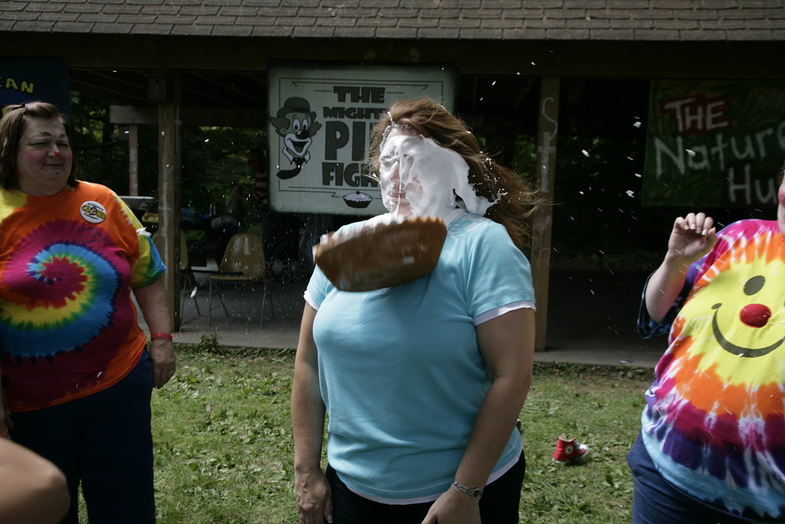
This Photo by Unknown Author is licensed under CC BY-SA-NC
Who wants to have a little extra fun after the WGM Inspection!!!???
Who wants to throw a pie in the face of Shawna Jolly, the Youth Committee Chairman, WGM Debbie or WGP Todd? I know that I would, but I can’t very well hit myself with a pie.
Any Chapter, or individual person that donates directly to the OES Scholarship will have their name placed in a hat. We will draw 6 names, and that person or Chapter member will be able to throw a pie at the person of their choice.
You have until May 1, 2026, to make your donations. If you have any questions, please reach out to Shawna Jolly, shawnajollyoes@yahoo.com ; Donya Wright or Gregory Kita.

