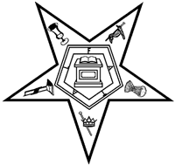
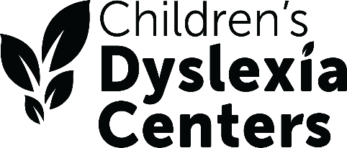

November 30, 2025

Dear Sisters and Brothers,

The Grand Chapter Committee for the Children’s Dyslexia Centers requests your assistance to help the children at the Centers reach their full potential. Dyslexia affects 1 out of every 5 individuals, making it the most commonly diagnosed learning disability in the country. Left untreated, the children often drop out of school and have a difficult time reaching their full potential.

I don’t know if you have ever attended any graduation ceremonies at one of the Centers. I have and it is very inspiring to hear the children and their families talk about how the tutoring they received changed their lives. Being able to succeed at school has a great impact on their self-esteem and confidence in all areas of their life.

The Centers also certify tutors on using the Orton-Gillingham approach to multisensory teaching.

Ohio is lucky to have 7 Children’s Dyslexia Centers across the state in Cambridge, Cincinnati, Canton, Cleveland, Columbus, Dayton, and Norwood. We are asking our Eastern Star Chapters to continue supporting those Centers through your donations.

All of the Centers have different needs and different amounts of space to store supplies. Therefore, we are again asking for donations of Amazon Gift Cards that the Centers can use in what every way meets their needs. This was a very successful project with last year’s committee and thank you to Kim for letting me recycle it.

Once again Chapters who make the $25 donation will receive a certificate of appreciation. Those Chapters donating $50 or more will also be recognized on the big screen at the 2026 Grand Chapter session.

Many of the Chapters located close to a Center already help that Center in some way and I would like to know about those activities. Please remember that those donations to the Center should NOT be sent to the Grand Secretary but directly to the Center being supported.

We would appreciate your Amazon cards and letters sharing the other ways you support the Centers being sent by the end of May. The Amazon cards, along with the receipt may be sent to: Brooke Anderson, 5405 Heritage Dr., Nashport OH 43830.

Thank you for your support of the Children’s Dyslexia Centers.

Brooke Anderson (485), Chairperson
Donna Garret (479)
Gary Nordmoe (140)

