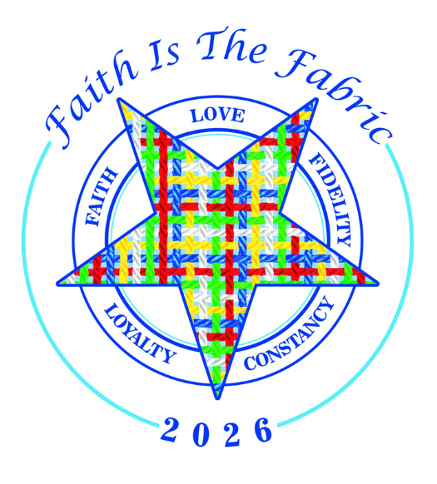
You are cordially invited to the
Northeast Zone
Districts 1, 2, 3, 4, 13 & 14
2026 Grand Officer Exemplification
& Circle of Knowledge Test
Saturday, February 21, 2026
Falls Masonic Temple
2307 Sackett Avenue
Cuyahoga Falls, OH 44223
Schedule of Events
10:00 am – Circle of Knowledge Test/Second Floor
10:00 am – 12:30 pm
Registration - Lobby
Steering Committee Tables – Dining Room
1:00 pm – Grand Officer Exemplification – Chapter Room
Bring your Red Book, Ritual, Notebook & Pen
Dress: Appropriate Chapter Attire

