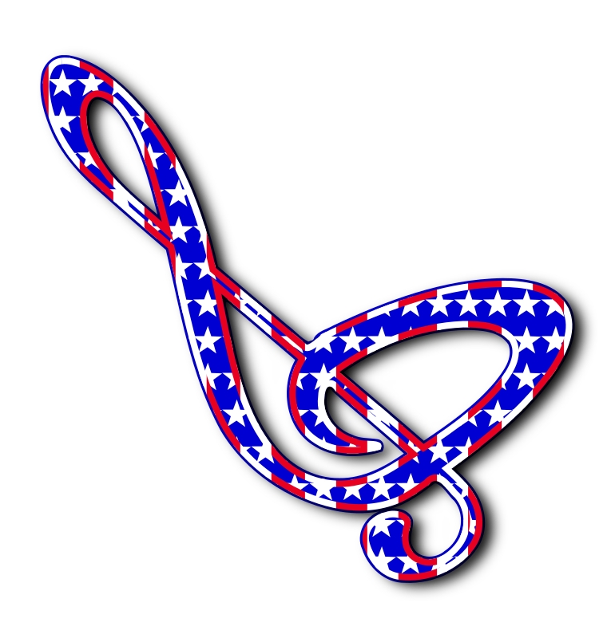
YONDOTA CHAPTER #317

ORDER of the EASTERN STAR
Invites You to the

ANNUAL INSPECTION OF OFFICERS

TUESDAY, APRIL 7, 2026
7:30 P.M.
SONGS OF FREEDOM
Paragon 788 Masonic Lodge
24845 OH-51 W (Woodville Road)
Millbury, OH 43447

Melissa Holmes
Grand Conductress
Inspecting Officer


Patti Logan Tim Wolf
Worthy Matron Worthy Patron
Refreshments to Follow

