Let Your Light Shine!

Bellefontaine Chapter #459
Invites you to the Inspection of Officers
April 8, 2026 at 7:00 pm
600 N. Main St., Bellefontaine, OH 43311

Inspecting Officer: Bonnie Spurling

Home Chapter of
Susan Corwin, 2026 Grand Chaplain
Garis Pugh, Aide to Grand Chaplain

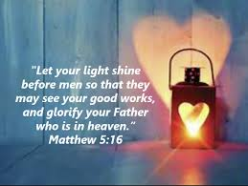

Heather Wood, W.M
Chuck Wood, W. P.
Judy Vassar, Secretary

Refreshments will follow in the dining room.

