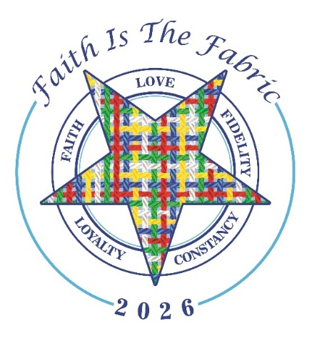

Please Join Districts
5, 6, 7, 8, 10, 11, 12 & 26
of the Northwest Zone

for a

2026 Grand Officer Exemplification

Saturday May 16, 2026

Lima Masonic Center
2165 North Cole Street, Lima, Ohio 45801
1:00 PM

Registration
10:00 - 12:30

Please have your DUES CARDS available.

The Circle of Knowledge Test
will be conducted at 10:00 AM
(No advance registration is required)

Lunch will be available for Grand Officers & their companions, members taking the Circle of Knowledge Test and Steering Committee Workers – reservations required. See attached form.

Due to member allergies, it is requested that those attending avoid wearing perfume. Hand sanitizer also will not be available. Thank you for your cooperation.

