Bellefontaine Chapter #459
cordially invites you to attend a

Grand Visitation and Reception

By the Worthy Grand Matron Debbie Somerlot
and the Worthy Grand Patron Todd Evans

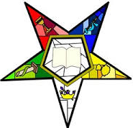
Susan Corwin
2026 Grand Chaplain

Friday, May 1, 2026
7:00 PM
600 N. Main Street, Bellefontaine, OH 43311

Join us to let your light shine with refreshments and entertainment.

In keeping with the message of Matthew 5:16 to let our light shine through good works, Susan asks that donations to ESTARL be considered in lieu of gifts.

