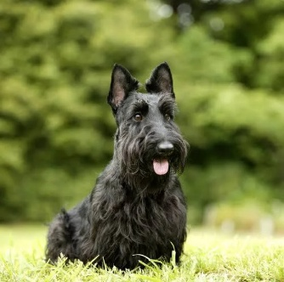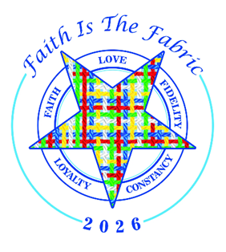
Welcome to the 2026 Charities Extravaganza
We hope you will join us on Saturday, June 27, 2026 at the Ohio Eastern Star Home
1451 Gambier Road, Mt Vernon, OH 43050.
Debbie and Todd have chosen a Highland Games Theme for this Extravaganza.
Dress is anything plaid but no jeans.
Registration will begin at 10:30
There will be games starting at 10:45 in the chapter room with lunch to follow at 12 in the dining room. The live auction will begin at 1:30.
Lunch is a cold cuts sandwhich with soup and tossed salad and cookies for dessert. Gluten free options will be available.
Reservations are due by May 15 2025. There is a limit of 240 people so get your reservation in early. Send $30.00 to Brenda Slay at 5429 Langwell Dr Westerville, OH 43082. Checks payable to District 11 Association with memo section stating: Charities Extravaganza. Please include the sign up sheet with the names of people attending.
There will be items from each District Charity Director for you to bid on before lunch and the live auction will follow lunch at 1:30.
This is a fund raiser for charities so every seat must be paid for to attend.
Thank you,
Co-Chairs State Charity Committee
Brenda Slay and Amy Wood

