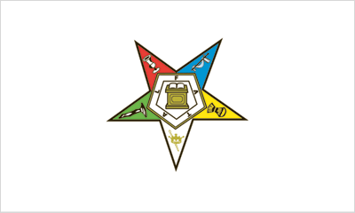
ORDER OF THE EASTERN STAR
Athens Chapter #175
Cordially invites you to attend
Our Annual Inspection of Officers
Monday, May 11, 2026
at 7 pm
Athens Masonic Temple
12 W Carpenter St., Athens Ohio
Refreshments after the meeting

Inspecting Officer: Associate Grand Patron Dennis Evans
Worthy Matron Melissa Knight
Worthy Patron Jeff Slattery
Secretary Debbie Balding

