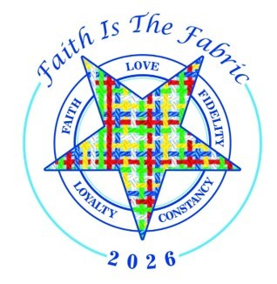
2026 Ohio Grand Chapter
"Faith is the Fabric" Grand Banquet
September 26, 2026 – 6:30 P.M.
Doors open at 5:45

This form is for printing and mailing a check payment for individual or multiple registrations for the Grand Banquet.

Make your check or money order payable to Grand Chapter of Ohio, OES Inc.
Postmarked by September 1, 2026

MENU:
There are three menu options to choose from:

- Brined Chicken Breast Pan Seared and topped with a Hunter Style Velouté
Fall Salad with Romaine, Heirloom Carrot Curls, Heirloom Tomatoes and Golden Beets with a
Choice Ranch of Balsamic Dressing
Mashed Potatoes
$54.00

- Braised Beef Short Rib
Fall Salad with Romaine, Heirloom Carrot Curls, Heirloom Tomatoes and Golden Beets with a
Choice Ranch of Balsamic Dressing
Braised Beef Short Rib with Red Wine Dem Sauce
Mashed Potatoes
$69.00

- Vegan and Gluten Free Plated Meal
Seasonal House Salad with Iceberg Lettuce, Tomatoes and Shaved Carrots with a choice of
Ranch or Balsamic Dressing
Portobello Mushroom with Seasonal Noodled Vegetables
Roasted Sweet Potatoes
$49.00
Each menu selection includes:
Chef's Selection of Seasonal Vegetables
Warm Rolls and Butter
Decaf Coffee, Assorted Herbal Teas, Iced Tea and Iced Water
Lemon Pound Cake and a Gluten Free Dessert

Mail form and check or money order to:

Cathy Adams
Grand Chapter Banquet Chair
5431 Mount Tabor Rd.,
Chillicothe, OH 45601

cathyoessect@gmail.com
740-703-0926

Name of person completing form:
Telephone: Email:

For groups that wish to sit together for the Grand Banquet, they should select a group name and ensure it is entered on each registration form (ex. 2022 Grand Family, District or Chapter, etc.)

Group Name if applicable_______________________________________________________
NAMES OF ATTENDEES: | TITLES: | Menu Selection | Chicken - $54.00  Beef - $69.00  Vegan - $49.00

Total Attendees_________________ Total Amount Due: _____________

*Use back or separate sheets to add more names.

