First Aid Committee
Imagine the following scenario…
You are at Grand Chapter and pass out. The nurses on the First Aid Committee provide emergency treatment and the local rescue squad is called for additional care and to transport you to the local hospital. You start to wake up and want them to call someone, but you can’t remember or say their name or phone number. What happens next?
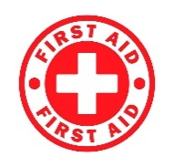
Again this year at Grand Chapter we are requesting all participants legibly complete an Emergency Information Form prior to Grand Chapter and then bring it with you. Please keep this form with you. We suggest you put this form with your credentials that you have hanging around your neck. This way, in case of an emergency, the members of the First Aid Committee will know where to find the form. It will not do us any good if it is in your hotel room and not with you.
This is your personal health information, and its contents are confidential and will only be made available to appropriate medical personnel. Extra Emergency Information Forms will be available at the First Aid station during Grand Chapter. Thank you for your cooperation.
Click here to download the form.
If you have any questions, please contact Dorothy Berman, BSN, RN-C, First Aid Chairperson at dottieb686@aol.com

