Grand Chapter Flower Committee
Do you need a corsage, boutonniere or floral bouquet at Grand Chapter?
Perhaps for you Past Grand Matron, Past Grand Patron, Grand Officer, Deputy Grand Matron, Grand Representative, Grand Page/Grand Aide or other special person(s) during this 2026 “Faith is the Fabric” Grand Chapter session?
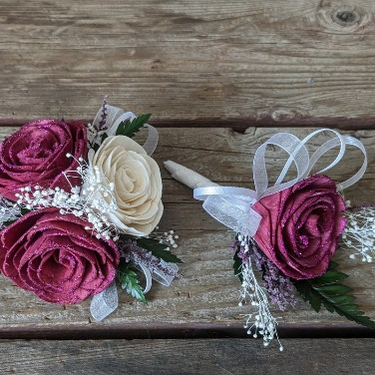
Please complete the Flower Order Form and mail or email to Jan Mason, Flower Committee Chairperson, at jmmason129@gmail.com
Flowers can be picked up at the Flower Table in the OES Marketplace on the dates and times listed on the Flower Order Form.
If you have any questions, please contact Jan.

